**SOFTWARE REQUIREMENTS SPECIFICATION**

**FOR**

**E-LEARNING MANAGEMENT SYSTEM**

**Prepared by**

**Sabidharshini P S (22EC132)**

**Sree Vishnu Varthini S (22EC162)**

**Sudheshna P (22EC173)**

**1.INTRODUCTION**

**1.1 Purpose**

The purpose of this Software Requirements Specification (SRS) document is to provide a comprehensive and detailed description of the e-Learning Management System (eLMS).The document gives the detailed description of the both functional and non-functional requirements proposed by the client.The main purpose of the e-Learning Management System (eLMS) is to facilitate the creation, delivery, management, and tracking of online educational courses.This project describes the hardware and software interface requirements using ER diagrams and UML diagrams.

**1.2 Document Conventions**

* Convention for Main title
* Font face: Times New Roman
* Font style: Bold
* Font Size: 14
* Convention for Sub title
* Font face: Times New Roman
* Font style: Bold
* Font Size: 12
* Convention for body
* Font face: Times New Roman
* Font Size: 12

**1.3 Scope**

The scope of the e-Learning Management System (eLMS) project encompasses the development of a robust online platform designed to facilitate the creation, delivery, and management of educational courses.

The system aims to provide a centralized platform where instructors can design and organize courses, students can enroll and access learning materials, and administrators can oversee the entire educational process.

The system will cater to the needs of educational institutions, training organizations, and businesses seeking to offer and administer online learning experiences.

**1.4 Definitions, Acronyms and Abbreviations**

* SQL - Structured query Language
* ER - Entity Relationship
* UML - Unified Modeling Language
* IDE - Integrated Development Environment
* SRS - Software Requirement Specification

**1.5 References**

* **Books**
* Software Requirements and Specifications: A Lexicon of Practice, Principles and Prejudices (ACM Press) by Michael Jackson
* Software Requirements (Microsoft) Second Edition By Karl E. Wiegers
* Software Engineering: A Practitioner’s Approach Fifth Edition By Roger S. Pressman
* **Websites**
* <http://www.slideshare.net/>
* [www.geeksforgeeks.com](http://www.geeksforgeeks.com)

**2. OVERALL DESCRIPTION**

**2.1 Entity Relationship Diagram**

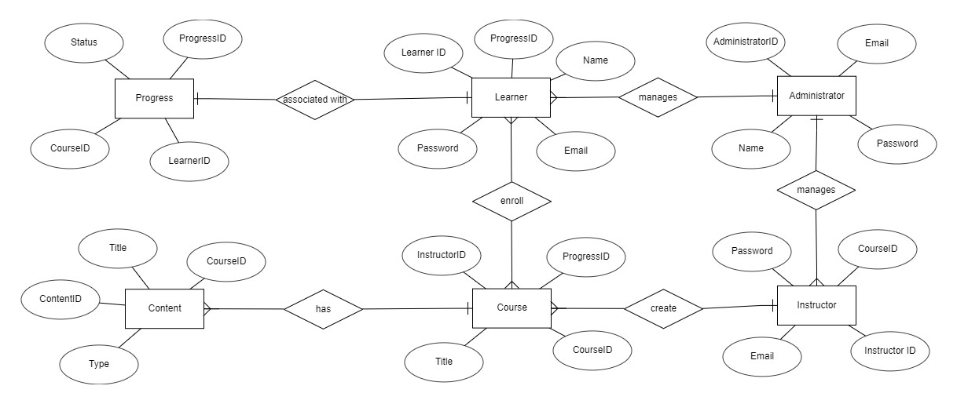

**2.3 User Classes and Characteristics**

**Admin:**

* Central administrator with comprehensive control over the e-Learning Management System.
* Manages courses, including creation, updating, and assignment of instructors.
* Handles user management, creating and managing accounts for instructors and students.
* Accesses reports and analytics to monitor user engagement, course progress, and system performance.

**Instructor:**

* Educator responsible for creating and delivering courses within the eLMS.
* Elevated privileges for course creation, module development, and assessment design.
* Monitors and tracks the progress of enrolled students.
* Communicates with students through announcements and messaging features.

**Student:**

* Primary learner with access to courses and materials assigned by instructors.
* Enrolls in courses offered within the eLMS.
* Accesses course materials, including lectures, assignments, and quizzes.
* Monitors personal progress within enrolled courses.
* Engages in discussions with instructors and peers.
* Seeks clarification on course content when needed.

**2.4 Operating Environment**

The E-Learning Management System will primarily operate in a Windows environment, ensuring compatibility with Microsoft Internet Explorer, Google Chrome, and Mozilla Firefox, with a specific emphasis on compatibility with IE 6.0. Additionally, most features will seamlessly function with Mozilla Firefox and Opera 7.0 or higher versions, expanding accessibility for users across popular browsers.

**2.5 Assumptions & Dependencies**

* Assumptions for the e-Learning Management System (eLMS) Project:
* Users have reliable internet access to use the eLMS.
* Users, especially administrators, are familiar with basic e-Learning system functionalities.
* The selected technology stack is compatible with users' devices and browsers.
* Instructors will upload accurate and relevant course content.
* Users will actively engage with the eLMS and participate in courses.
* The database storing user information and course data is reliable and secure.
* The eLMS operates 24/7 without significant downtime.
* User authentication processes, including usernames and passwords, are effective and secure.
* Dependencies for the e-Learning Management System (eLMS) Project:
* Successful operation depends on specific hardware and software configurations.
* Certain features need to be developed before others to ensure a logical and functional sequence.
* Integration with external libraries or APIs is required for specific functionalities.
* The successful implementation depends on users, especially administrators, having a clear understanding of the eLMS.
* The project depends on accessible databases storing accurate information about users, courses, and progress tracking.
* The project relies on the implementation of secure authentication and data protection protocols.
* Any updates or modifications to course content and user data depend on accurate recording in the database.
* The success of the project is dependent on maintaining accurate and up-to-date data, specifically regarding courses, users, and progress tracking.

**2.6 Configuration**

**Software Configuration:**

This software package for the e-Learning Management System (eLMS) is developed using Java as the front end, supported by Sun Microsystems. The development environment includes Java Runtime Environment for the front-end development. The back end is powered by Microsoft SQL Server, serving as the database management system.

**Software Components:**

* Front-end Language: Java
* Front-end Development Environment: NetBeans 7.0.1
* Back-end Database: Microsoft SQL Server
* Operating System Compatibility: Windows

**Hardware Configuration:**

The hardware configuration for the eLMS project is designed to ensure optimal performance and efficiency.

* Processor: Pentium(R) Dual-core CPU
* Storage: Hard Disk: 40GB
* Memory: RAM: 256 MB or more

This configuration is selected to accommodate the requirements of the e-Learning Management System, providing sufficient processing power, storage capacity, and memory to support smooth operation and data handling.

**3. SYSTEM FEATURES**

The e-Learning Management System (eLMS) is designed to provide a comprehensive and user-friendly platform for delivering and managing online courses. The following features outline the key functionalities of the eLMS:

**3.1 User Management**

**3.1.1 User Registration and Authentication:**

* Instructors and students can register with the eLMS using valid credentials.
* Secure authentication mechanisms ensure the protection of user accounts.

**3.1.2 User Roles and Permissions:**

* The system supports distinct roles such as Instructors, Students, and Administrators.
* Granular permissions are implemented to control access to various system functionalities.

**3.2 Course Management**

**3.2.1 Course Creation:**

* Instructors can create courses by defining modules, lessons, and assignments.
* The system provides tools for uploading diverse content types, including text, multimedia, and interactive elements.

**3.2.2 Course Enrollment:**

* Students can easily browse and enroll in available courses.
* Enrollment confirmation and access to course materials are automated.

**3.3 Content Delivery and Assessment**

**3.3.1 Multimedia Content Delivery:**

* The eLMS supports the delivery of multimedia content, including videos, documents, and interactive materials.
* Responsive interfaces ensure a seamless learning experience.

**3.3.2 Assessments:**

* Instructors can create and administer assessments, including quizzes and assignments.
* The system supports automated grading and feedback mechanisms.

**3.4 Progress Tracking and Analytics**

**3.4.1 User Progress Tracking:**

* Both instructors and students can monitor progress within enrolled courses.
* Visual representations and detailed analytics provide insights into user engagement.

**4. FUNCTIONAL REQUIREMENTS**

The e-Learning Management System (eLMS) prioritizes a dynamic and user-centric graphical interface for both instructors and students, promoting an engaging and efficient learning experience. The GUI is designed to facilitate seamless navigation, interaction, and customization.

* The GUI shall feature an intuitive design, ensuring a user-friendly experience for both instructors and students.
* Instructors and administrators shall have access to quick reports and analytics, providing insights into course enrollment, completion rates, and user engagement within specified time frames.
* The GUI shall offer robust search functionality, empowering users to explore courses based on diverse criteria, including course titles, instructors, and keywords.
* All modules within the eLMS, such as course creation, progress tracking, and assessments, shall seamlessly integrate into the GUI, adhering to a standardized and consistent layout.
* The GUI shall be responsive across various devices, and its design shall follow a standardized template to ensure a cohesive and familiar interface.

**4.1 User Authentication and Login Interface**

* New users can register by entering required details, and the GUI shall guide them through the account creation process.
* The login interface shall prompt users to enter their credentials securely. Incorrect entries will trigger error messages to ensure the security of access.

**4.2 Progress Tracking**

* The GUI shall include a user dashboard that allows students and instructors to track progress, view upcoming assignments, and access relevant course information.

**5. NON-FUNCTIONAL REQUIREMENTS**

**5.1 Data Requirements**

The e-Learning Management System (eLMS) relies on specific data elements for its functionalities. User data includes full names, usernames, email addresses, roles, and profile pictures. Authentication data involves encrypted passwords, security tokens, and last login timestamps.

Course data encompasses details like titles, identifiers, descriptions, start and end dates, and instructor information. Assessment data includes assessment titles, types, due dates, and grading weightage. Progress tracking data monitors completed modules, lessons, assignments, user activities, and course progress.

**5.2 Security Requirements**

* Ensuring the safety and security of the e-Learning Management System (eLMS) is paramount. The following security requirements are vital for safeguarding user data and maintaining system integrity.
* The system shall utilize a secured database to protect sensitive information, employing encryption and secure access protocols.
* Normal users shall have read-only access, with restrictions on editing or modifying any data, except for their personal information.
* Different user types shall have distinct access constraints, ensuring that each user operates within predefined roles and permissions.
* Robust user authentication mechanisms shall be implemented, verifying the identity of users through secure protocols.
* Stringent measures shall be in place to prevent unauthorized access and hacking attempts on users' passwords, ensuring the confidentiality of login credentials.
* Distinct accounts shall be maintained for administrators and members. Admin accounts exclusively possess rights to update the database, guaranteeing restricted access to sensitive information.

**7. CLASS DIAGRAM**

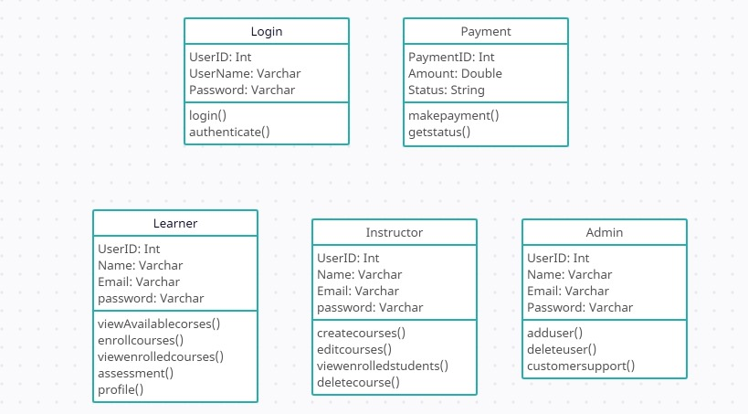

**8. OTHERS**

**Appendix:**

A - Admin, Abbreviation, Acronym, Assumptions; B - Books, Business rules; C - Class, Client, Conventions; D - Data requirement, Dependencies; G - GUI; K - Key; L - Library, Librarian; M - Member; N - Non-functional Requirement; O - Operating environment; P - Performance, Perspective, Purpose; R - Requirement, Requirement attributes; S - Safety, Scope, Security, System features; U - User, User class and characteristics, User requirement.

**Glossary:**

In this document and the associated project, the following conventions and acronyms are utilized:

* Administrator: A login ID denoting a user with user administration privileges for the software.
* User: A general login ID assigned to most users.
* Client: The intended users for the software.
* SQL: Structured Query Language, employed for retrieving information from a database.
* SQL Server: A server utilized for storing data in an organized format.
* Layer: Represents a distinct section of the project.
* User Interface Layer: The segment of the assignment referring to what the user interacts with directly.
* Application Logic Layer: The section of the assignment related to the Web Server, where all computations are completed.
* Data Storage Layer: The part of the assignment referring to where all data is recorded.
* Use Case: A comprehensive diagram illustrating a basic overview of the project.
* Class Diagram: A type of static structure diagram describing the system's structure by illustrating the system’s classes, their attributes, and the relationships between the classes.
* Interface: Something used to facilitate communication across different mediums.
* Unique Key: Employed to differentiate entries in a database.